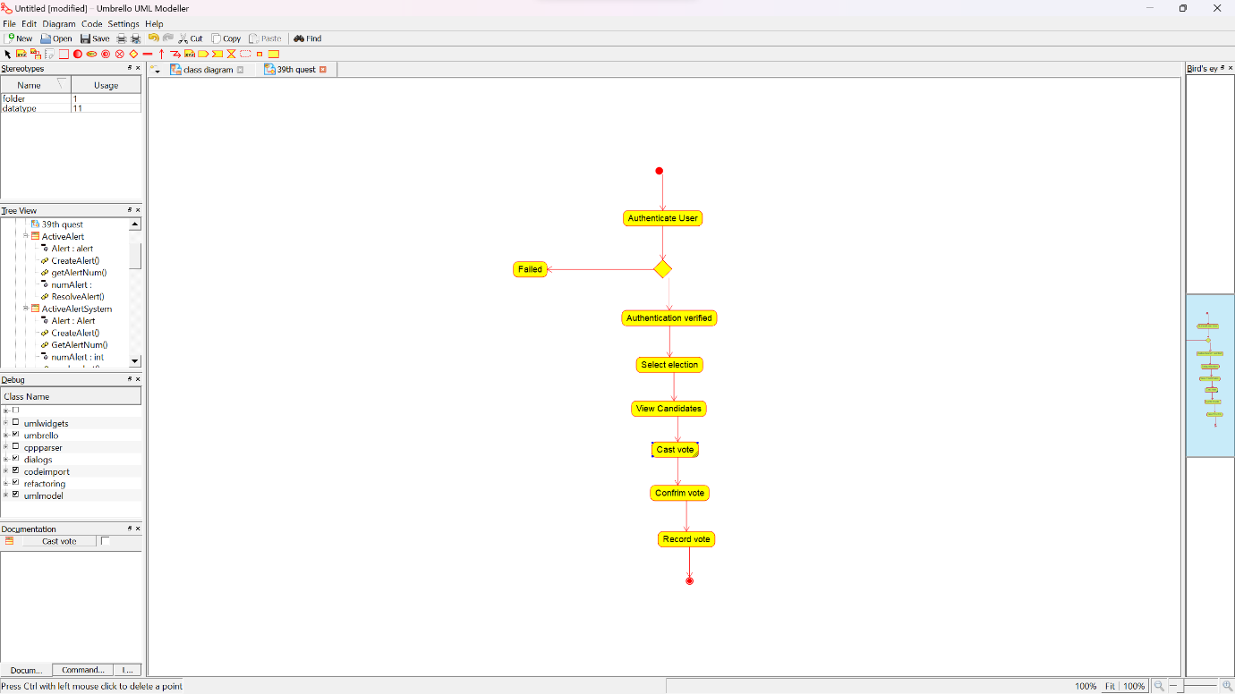ACTIVITY DIAGRAM: 39th question

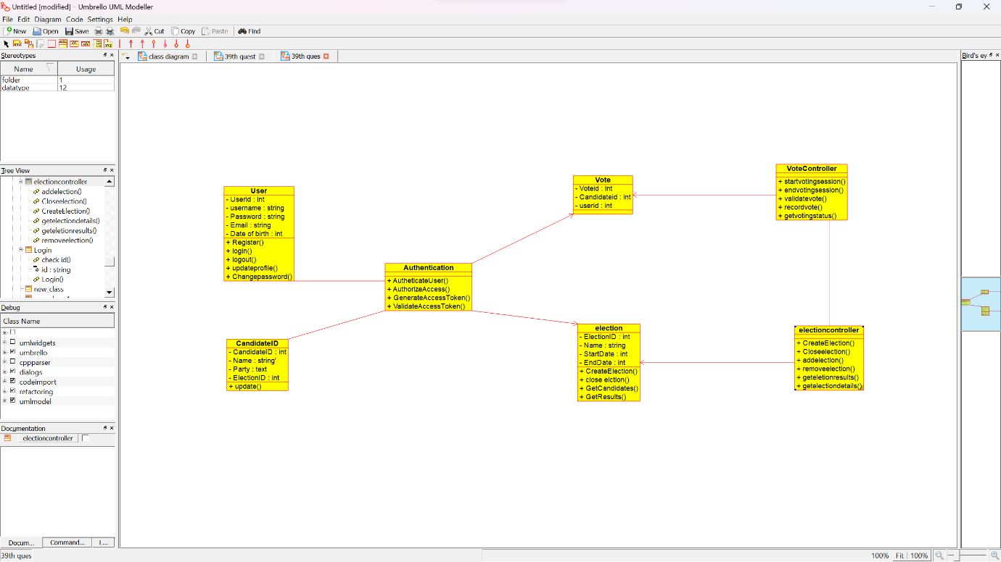CLASS DIAGRAM: 39th continue

9.AIRLINE RESERVATION USE CASE DIAGRAM:

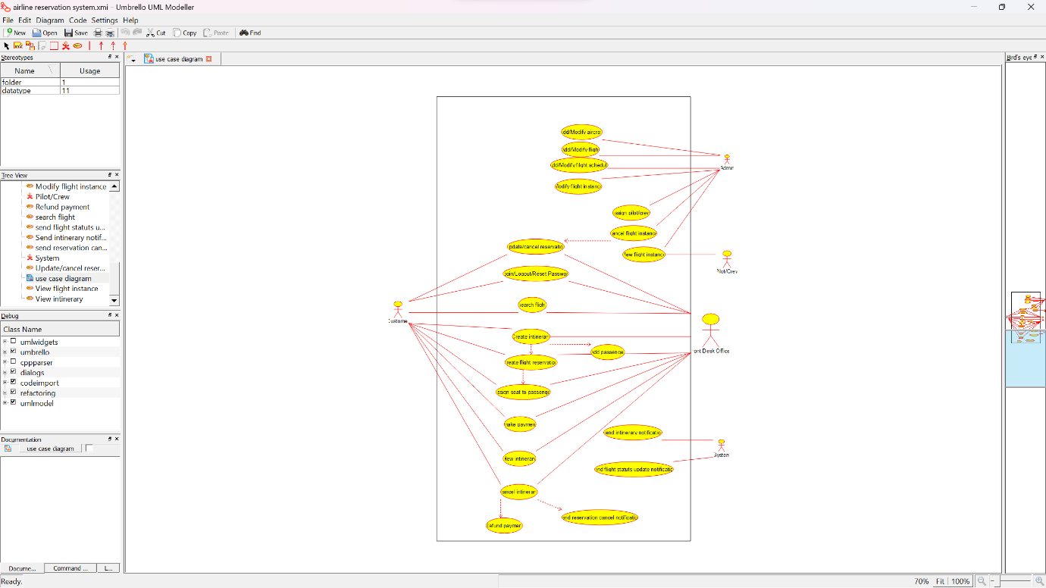

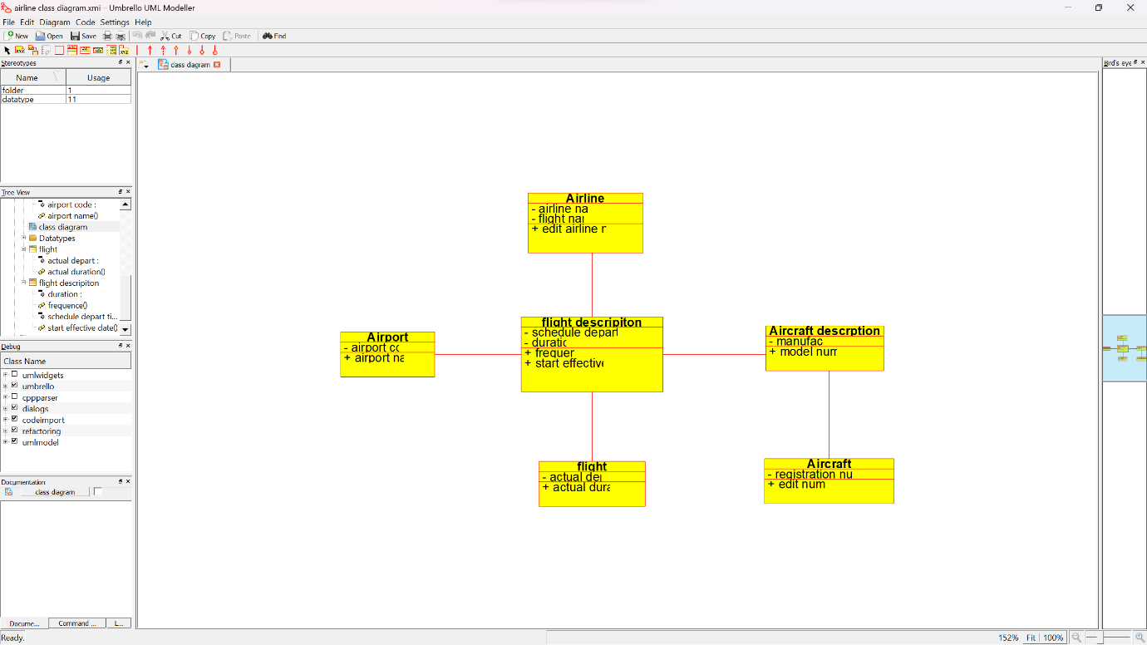10.AIRLINE RESERVATION CLASS DIAGRAM:

37.E-WALLET USECASE DIAGRAM:

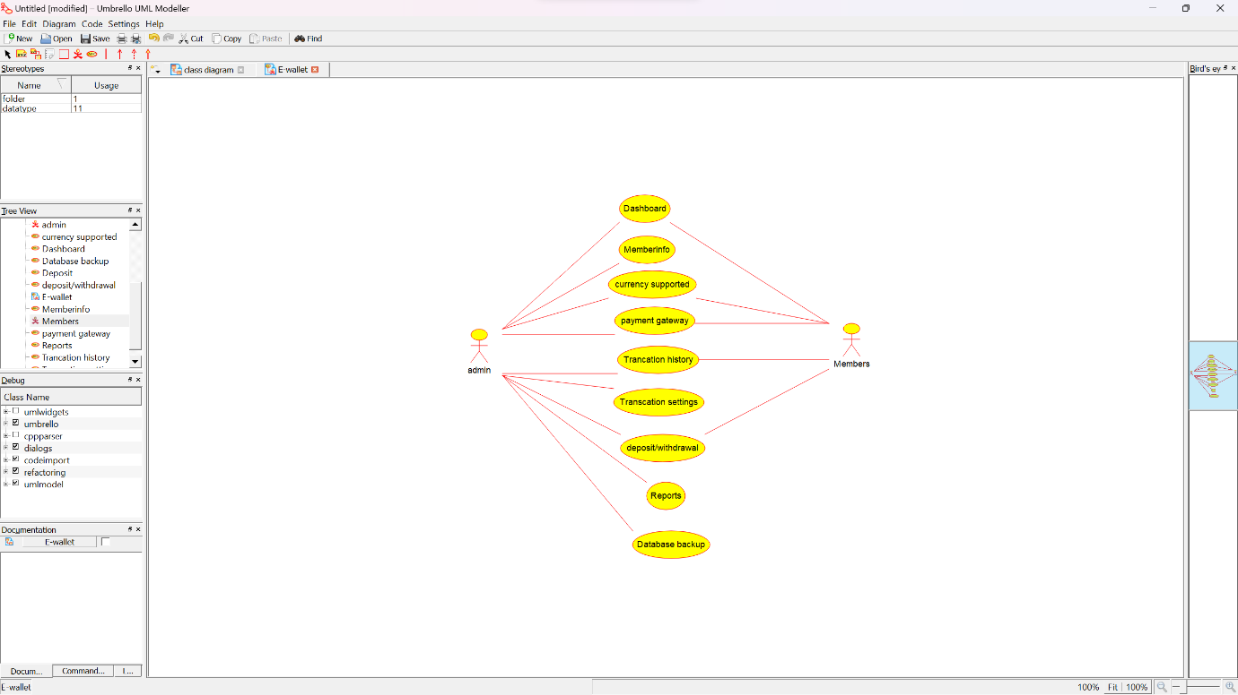

38.ONLINE SECURITY SYSTEM MANABGEMENT CLASS DIAGRAM:

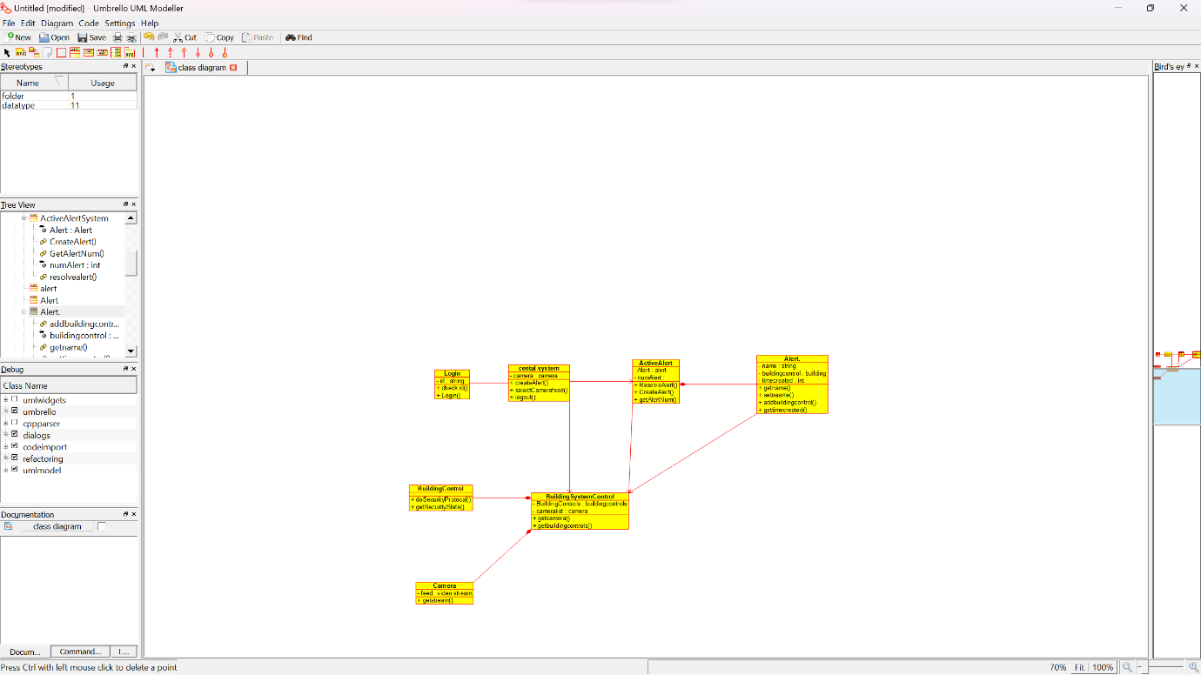

4.SHOPPING CART SYSTEM USE CASE:

